
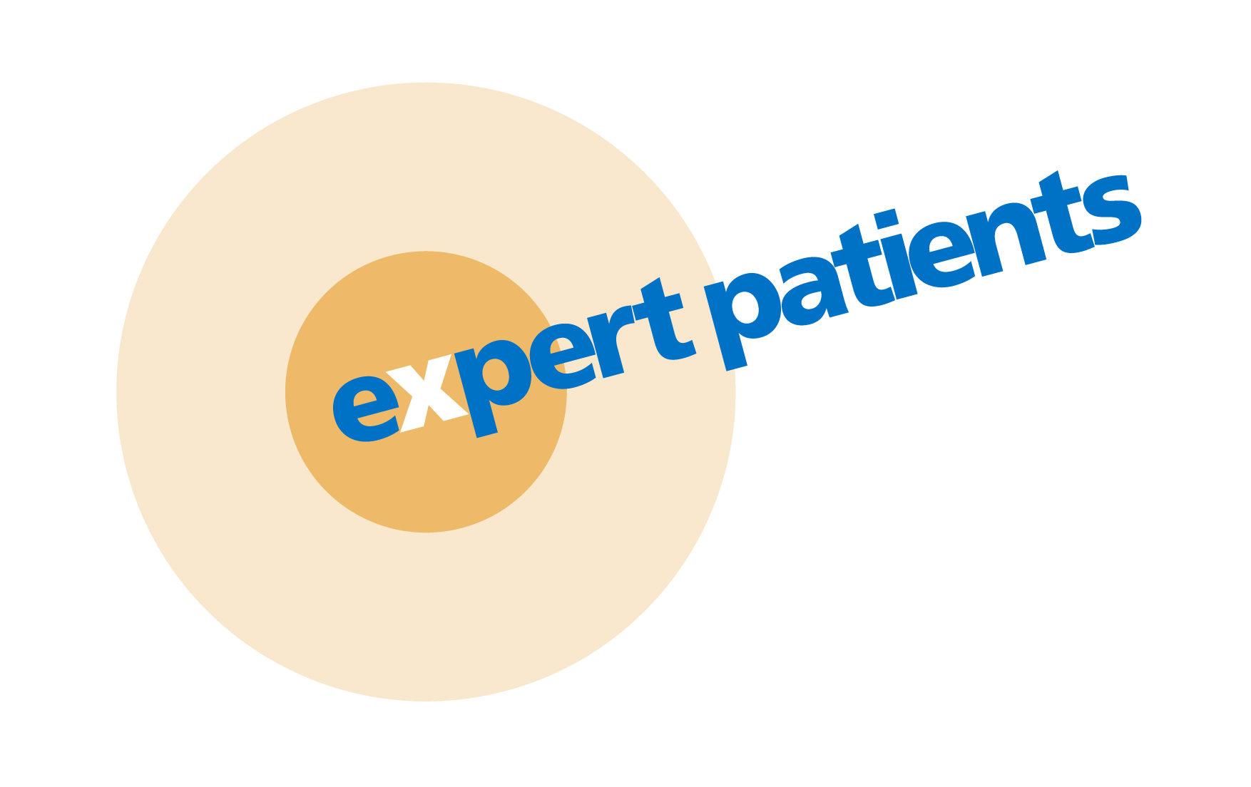

EPP Self-Management Course

[Information Leaflet for people who live in Islington or Haringey]

What is it?

The Expert Patients Programme (EPP) is a six-week course for anyone living with one or more long term health conditions such as asthma, chronic fatigue, COPD, depression, diabetes, heart disease, MS, Parkinson’s disease, HIV, ME, on-going back pain etc.

The course is designed to help you cope with your health condition, find solutions to common problems & feel more in control.

What can self-management offer me?
People with long-term health conditions face many similar issues such as fatigue, pain, frustration, stress and depression. The course looks at how to manage these whilst working alongside your healthcare providers.

By participating in the course you will:
- Learn new skills to manage your health condition better
- Develop confidence in the daily management of your specific condition
- Meet others and share similar experiences
- Learn about developing more effective relationships with health professionals.

What do we learn?
The course focuses on what you can do, rather than what you can’t. Weekly sessions cover useful topics such as managing symptoms, dealing with pain and tiredness, coping with depression and other feelings, relaxation techniques, healthy eating, exercise, setting realistic goals and communicating effectively with health professionals.

How has it helped other people?
People who have taken part in an EPP course have reported that it has helped them to:
- Feel confident and more in control of their life
- Manage their condition and treatment together with healthcare professionals
- Be realistic about the impact of their condition on themselves and their family
- Use their new skills and knowledge to improve their quality of life.

Do I need to pay?
No, it is free.

Do I need to be referred by my doctor?
No, the course is open to self-referrals as well as referrals from doctors and other professionals.

How is it structured?
Each course runs for two-and-a-half hours a week, for 6 weeks. There is one session a week and refreshments are provided. A maximum of 16 people attend the course. All participants have different conditions.

Do I need to talk about my own condition?
There will be times where you will be talking about how your condition affects your life and what you would like to change, however it is up to you what you want to share and how much detail you want to give. All discussions are confidential.

Who are the tutors?
The course is run by two trained tutors who themselves have long-term conditions.
More info overleaf

Where are the courses held?
The courses are held in well-located community and health care venues, with facilities such as toilets and disabled access at the venue, as well as comfortable chairs and good access to public transport. You are free to stretch your legs, get up and walk around if you need to. It is not a hospital setting.

Will there be someone to care for me at the course?
You need to be able to care for yourself during the course, as the tutors can not assist you with personal care.

You can bring a carer or assistant if you wish. Please bear in mind that if you are related to your carer (e.g. husband or wife) it may be difficult for you to discuss certain issues freely. This is your time to talk about managing yourself. If you decide you would like your carer to be present, they can either take part as a participant or sit outside the room. Please notify Islington Self- Management Co-ordinator on 020 7527 1189 or Davina Ledermann, Haringey Self-Management Co-ordinator on 020 7527 1707 or email whh-tr.Self-Management@nhs.net beforehand if you are likely to bring a carer or assistant.

I have specific communication requirements – can these be accommodated?
All communication requirements can be discussed with Islington Self- Management Co-ordinator on 020 7527 1189 or Davina Ledermann, Haringey Self-Management Co-ordinator on 020 7527 1707 or email whh-tr.Self-Management@nhs.net
We have large-print materials available and BSL interpreters can be arranged.

Do you provide transport?
We do not normally provide transport however if lack of transport would prevent you from attending, please contact Islington Self- Management Co-ordinator on 020 7527 1189 or Davina Ledermann, Haringey Self-Management Co-ordinator on 020 7527 1707 or email whh-tr.Self-Management@nhs.net to discuss your requirements.

Do I have to attend every week?
Yes, it is advised that you do in order to get the most out of the course. We do understand that there may be sessions you will miss due to appointments or feeling unwell.

What do participants say?
“I really looked forward to coming here every week & meeting other people who inspired me. The tutors conducting EPP were first class.”

“Meeting people has helped me understand more about myself and ways of managing things… It has been a well run course and everyone has been very helpful and caring.”

“It has helped me become more aware of my condition and how it affects me, and to feel that I can manage it to some extent through pacing, diet and relaxation techniques.”

“There’s a mix of people with different conditions on the course so it’s a good leveller.”

“It gave me more information and confidence to do normal things in life.”

